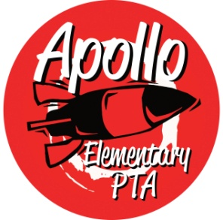**Apollo Elementary PTA**

**General Meeting Agenda**

**September 28, 2022**

6:30-6:35pm Call to Order

6:35-7:05pm Guest Speaker—Sydney Hall, school Counselor

7:05-7:15pm Rocket Report—Principal Harris

7:15-7:35pm Presidents’ Report & Welcome—Laura Ni & Rachel Hearn

* Vote 2022-23 Goals and Mission Statement
* Vote 2022-23 Standing Rules
* Approve Calendar for 2022-23

7:35-7:45pm Treasurers’ Report – Erin Wang

* Annual Financial Review for 2021-22
* Financial Statement
* Vote 2022-23 Budget

7:45-7:55pm Secretary’s Report – Jen Davis

* Approval of Minutes from June 2022

7:55pm-8:10pm Director Introductions

* Programs – OPEN (Laura)
  + Fall Scholastic Book
  + Math In Action
  + Reflection
  + School Supplies
* Events – Nancy Yeung
* Fundraising – Sarah Silverman
  + Fall Rocket Fuel Fundraising: 10/3 -10/14.
  + Spiritwear
* Communications – Laura Ni
* Volunteers – OPEN (Laura)
  + Picture Day
  + Vision and Hearing
  + Book Fair

8:10-8:25pm Standing Committee Introductions

* ISF – Michelle Kauffman
* Membership – Jennifer Khumalo
* Art – Laurelle Graves
* Family & Community Engagement (FACE) – OPEN
* Outreach –Yomn Yasser & Lisa Lee
* Parent Ed/Parent Wiser—Laurelle Graves
* Teacher Liaison – Jen Davis
* Special Needs—Andrea McMillan & Jennifer Khumalo
* Safety – Laurelle Graves & Lisa Lee

8:25 – 8:30 New Business

8:30pm Adjourn